**Manual Press Juicer Improvement Project**



**Prepare For:**

**Dr. Weihang Zhu**

**Department of Industrial Engineering, Lamar University**

**Email: weihang.zhu@lamar.edu**

**Phone: 409-880-8804**

**Address: PO Box 10032**

**Beaumont, TX 77710**

**Prepared By:**

**Isaiah Gerald**

**Email: Igerald1@lamar.edu**

**Raghada Ajel**

**Email: raghdaajel@gmail.com**

**Course: INEN-4345**

**Semester: Spring 2017**

**Contents**

* **Original Abstract ……………………………………………………………………….. 3**
* **Updated Abstract ………………………………………………………………………. 5**
* **Introduction ……………………………………………………………………………... 7**
* **Intro to Solid Modelling and CREO ……………………………………………….. 8**
* **Project Background ………………………………………………………………….. 10**
* **Original Design ………………………………………………………….………. (11-23)**
  + **Excelvan’s Manual Juicer (Picture) ……………………………………. 11**
  + **Assembly View (Original) ………………………………………………... 12**
  + **Exploded View (Original) ………………………………………………… 13**
  + **Part Design and Description (Original) ……………………...………. 14**
  + **Initial Take Away …………………………………………………………… 23**
* **Improved Design …………………………………………………..……………. (24-30)**
  + **Assembly View (Improved) …………………………………...………... 24**
  + **Exploded View (Improved) ……………………………………………... 25**
  + **Parts (Improved Only) …………………………………………..……….. 26**
* **Part Manufacturing Plan ………………………………………………………….… 30**
* **BOM ……………………………………………………………………………….. (31- 32)**
  + **Comparison ………………………………………………...….…………… 31**
  + **Part Quantities …………………………………………….....……………. 32**
  + **Comments on Complexity and Quality ……………………………..……. 32**
* **DFA Analysis …………………………………………………………………...……. (33)**
  + **DFA Guidelines ………………………………………………….….……… 34**
  + **Areas of Improvements …………………………………………………. 34**
* **Redesigned Parts (DFA & DFM) …………………………………………………. 36**
* **Comparison (Original Vs. Improved) …………………………………………... 38**
* **Results ……………………………………………………..………………………….. (40)**
  + **Table …………………………………………………………………………. 40**
  + **Summary ……………………………………………………………………. 40**
* **Conclusions ……………………………………………………………………………. 41**
* **Team Contribution ………………………………………………………………….. 41**
* **References …………………………………………………………………………….. 42**

**Original Abstract**

***Objectives*:**

In the modern era of kitchen appliances there is an automated tool for almost anything. From dish washers to crock pots, many of the once time consuming and work intensive tasks have been reduced to formalities that require little if any effort. Despite all of the seemingly cutting edge and highly efficient innovative technology available, some people still desire basic, manually operated kitchen tools to complete their meals. Whether it be from the love of preparing food, an attempt to follow a current trend, or a necessity due to cost constraints, the demand for manual tools still exist and is relatively strong. Working from this idea, our team decided to apply the techniques of Design for Manufacturability and Design for Assemblability to Excelvan’s hand press juicer.

Excelvan’s design is relatively simple in nature and combines a strong and stable metal frame with a leveraged handle to squeeze juice from fruit with ease. The entire design consists of a metal assembly that has several basic components which include a U-shaped base, main support rod, circular juicing arm (that consist of an arm fixed to the rod and attached to a protruding metal cup to serve as the press base and hold the various cone and funnel options), Overhead handle and press mount, 4 handle and press bracket supports (2 on each side for better force distribution), handle lever, press, press rod, cones and funnels, and various connector pins, e-clips and bolts to hold it all together. In total it only consists of 20 parts and has profile that stands 16” (41 cm) tall, is 11” (28 cm) in length, and 7.5” (19 cm) wide. All parts contained in the upper portion, press base, and base are made of cast iron with only the main support rod, cones, and funnel being made of an alternate material (stainless steel) which make the entire assembly weigh a total of 6.4 lbs. Since this initial design is relatively simple and seems to provide good functionality it appeared as though making significant improvements might present a challenge, but using the techniques we have learned through this course we identified two specific areas were the product had short comings and could use re-evaluation on its design.

The first of these areas consist of several parts which included the entire upper portion of the tool. This area is the main force generator of its operation and also contains the greatest number of parts. Consisting of the lever arm, bracket supports, press, press rod, overhead handle and press mount, and several bolts and pins we considered it through a DFM/DFA examination and found that the assembly time and cost could be greatly reduced and durability increased through the elimination of these components and replacement with a simpler design containing less parts. This new design will also possess a reduced radius of force by making use of a gear type assemble to apply pressure. This gear type assemble will model its self closely to an automotive differential setup and should be a more efficient mechanical means which will be beneficial in reducing the material needed to create a longer handle by decrease the distance need to create the same amount of torque. By designing these components in this way we also hope to create a design that can be manufactured from structurally inferior materials without the loss of overall integrity. This will be accomplished by the use of the gear type assembly for force generation and tighter radius of operation.

The second area for improvement consists of the base with a thickness of 0.79” (2.0 cm) and lower mounting bracket containing the circular press platform. This area of the product will be redesigned to fuse these two separate components into a single incorporate part by extending the base upward. The creation of this part should allow for the product to be manufactured out of lighter and cheaper plastic materials.

***Management***

* + *Team Members*:

|  |  |
| --- | --- |
| * + - Raghda Ajel       * Roles:       * Engineer       * Co-Manager       * Analyst       * Designer       * Assembly Modeler       * Responsibilities:         + DFM         + Model Assembly (original)         + Model Parts (lower Assembly)         + Project Background         + Designed Assembly         + Redesign         + Summary       * Expected % of Workload:         + 50% | * + Isaiah Gerald     - Roles:       * Engineer       * Co-Manager       * Technician       * Designer       * Developer     - Responsibilities:       * DFA- Analysis for a part       * Model Parts (Upper Assembly)       * Model Assembly (improved)       * Manufacturing Plan for a part       * Intro to Solid Modeling/CREO       * Parts/Model Function       * Redesign     - Expected % of Workload:       * 50% |

**Updated Abstract**

***Objectives*:**

In the modern era of kitchen appliances there is an automated tool for almost anything. From dish washers to can openers, many of the once time consuming and work intensive tasks have been reduced to formalities that require little if any effort. Despite all the seemingly innovative and highly efficient technology available, some people still desire the touch and feel of manually operated kitchen tools to complete their meals. In the industrial scene, this can be observed as well with many manually operated kitchen appliances being develop with the strength and integrity to handle extreme use and little maintenance. These devices allow companies to capture this share of market, where people feel more comfortable with an open view of how their food is prepared Working from this idea, our team decided to apply the techniques of Design for Manufacturability and Design for Assemblability to Excelvan’s industrial hand press juicer.

Excelvan’s design, though relatively simple in nature, still has many complexities from its construction. This comes from the combined need for strength and stability which they incorporate into their metal frame with a gravity aided handle to squeeze juice from fruit. The entire design consists of a metal assembly that has several basic components which include a U-shaped base, main support rod, circular juicing arm (that consist of an arm fixed to the rod and attached to a protruding metal cup to serve as the press base and hold the various cone and funnel options), Overhead handle and press mount, 4 handle and press bracket supports (2 on each side for better force distribution), handle lever, press, press rod, cones and funnels, and various connector pins, e-clips and bolts to hold it all together. In total it only consists of 24 parts and has profile that stands 16” (41 cm) tall, is 11” (28 cm) in length, and 7.5” (19 cm) wide. Parts including the upper mount, press base, and base are made of cast iron with only the main support rod, handle, cones, and funnel being made of an alternate material (stainless steel) which make the entire assembly weigh a total of 6.4 lbs. This initial design is relatively simple and seems to provide good functionality, but through analysis of its design we were able to find areas were significant improvements might be made. Using the techniques we have learned through this course we identified two specific areas were the product had short comings and could use re-evaluation on its design.

The first of these areas consist of several parts which included the entire upper portion of the tool. This area is the main force generator of its operation and contains the greatest number of parts. Consisting of the lever arm, bracket supports, press, press rod, overhead handle and press mount, and several bolts and pins we considered it through a DFM/DFA examination and found that the assembly time and cost could be greatly reduced and durability increased through the elimination of these components and replacement with a simpler design containing less parts. This new design will also possess a reduced radius of force re-design its construction to be more centralized and compact. This assemble will work through means of a slider bar which will allow the handle to apply pressure directly over the press base. Using this design should be a more efficient mechanical means which will be beneficial in reducing the material needed to create a longer handle by decrease the distance needed to create the same amount of torque. By designing these components in this way, we also hope to create a design that can be manufactured from structurally inferior materials without the loss of overall integrity.

The second area for improvement consists of the base with a thickness of 0.79” (2.0 cm). This component of the product will be redesigned to improve stability and allow for safer operation. The creation of this part should allow for the product to be manufactured out of lighter and cheaper plastic materials.

***Management***

* + *Team Members*:

|  |  |
| --- | --- |
| * + - Raghda Ajel       * Roles:       * Engineer       * Co-Manager       * Analyst       * Designer       * Assembly Modeler       * Responsibilities:         + DFM         + Model Assembly (original)         + Model Parts (lower Assembly)         + Project Background         + Designed Assembly         + Redesign         + Summary       * Expected % of Workload:         + 50% | * + Isaiah Gerald     - Roles:       * Engineer       * Co-Manager       * Technician       * Designer       * Developer     - Responsibilities:       * DFA- Analysis for a part       * Model Parts (Upper Assembly)       * Model Assembly (improved)       * Manufacturing Plan for a part       * Intro to Solid Modeling/CREO       * Parts/Model Function       * Redesign     - Expected % of Workload:       * 50% |

**Introduction**

As we developed our understanding of the DFA methodology and made progress in creating the proper structure to implement it we first considered the objective of redesigning our product by examining the necessary components to complete the project. We found that Integrating our original product and any design improvements in CREO parametric would require a simultaneous process of trial and error. This involved running improvements and modifications through DFA guidelines, possible CNC processes, and complete assembly procedures then comparing these results to the original to see if they ultimately resulted in a realized addition in value. As our eventual goal for this project was to find a better economical and more sensible way to manufacture the product of our choice, we placed a huge emphasis on making sure any improvements would pass these rigorous tests.

Choosing an industrial manual juicer for our product resulted in extensive research on many related products in this market to form an outline on how far we could alter the products definition while preserving core functionality. This revealed the many variations across the market in terms of design, manufacturing process, and material makeup, however it was made clear that any improvements made would have to maintain the juicers ability to function under adverse industrial conditions with a high level of repeated use. It was also realized that our agreed upon improvements would need to make the juicer user friendly so an individual at any level of experience could easily and safely use it as well as make it compact for storage reasons.

With all of this in mind and little knowledge of the original manufactures processes and procedures due to lack of publicly available information we considered many factors in or improvement process. Applying DFA methods we resolved to limit the number of parts contained in the assembly. This led us to consider many designs to see which ones could be assembled with the fewest allotted parts, requiring several revisions. We also devised new methods of manufacturing the product with knowledge from our studies and debated on alternative materials to make the product lighter and more reliable.

This report details the steps we took to come to final results and demonstrates how we utilized CREO solid modeling to aid in our product design. Also, included in the report will be detailed notes, diagrams, images, drawings, and specifications on the improved design and how it compares to the original. This will include material on how these improvements made an impact on the overall design and what results followed.

**Intro to Solid Modeling and CREO**

In almost every field of manufacturing, the concept of solid modeling is a crucial component that has provided a critical function in product design and develop. Software implementing this concept allows engineers to accelerate the design process with increased accuracy while at the same time decreasing the cost and time associated with development. It boosts productivity by creating an environment to simulate realistic conditions these models might face once manufactured and also allows for the evaluation of aesthetic qualities related to possible consumer products which has become extremely important and customers require more options from producers.

The application of solid modeling software is limitless with the ability to provide geometric representations of designs with parametric details and complete information on associativity and connectivity between the designs components. This tool can be used to model everything from the smallest circuit boards to massive production facilities with intricate process flows and control schemes. The combination of this unique ability to model and simulate anything imaginable make utilization of this technology essential for most manufacturers to stay relevant.

This revolutionary modern engineering tool provides its high level of functionality through a software package that executes an efficient graphic user interface were 3D and 2D models can be created and viewed. In this system parts can be view at various scales and from various angles as well as in different views and layers. It allows for the user to implement specific boundaries to create the effect of physical limitations that might be present once the product is actually put into production such as volume, weight, and density. The basis for these modeling capabilities center around the concepts of solid modeling which consists of philosophies and mathematical techniques from ideas related to geometry and topology that are implemented through the software’s code to reduce complexity and make the process of modeling more manageable for the designer.

CREO is just one of the many available software packages which provide these capabilities. This solid modeling program brings its own set of unique tools, functions, and terminology to give users a somewhat different contextual environment to express their ideas through models. One of the key features of this modeling program is it’s easy to use interface that provide the plethora of tools available in a format that is relatable to most computer programs. It allows users to develop 3D models and 2D drawings with annotated dimensions and notes if desired and provides a robust platform to implement design intent and add constraints to form models that are easily modified to account for possible alteration in design. In addition to being able to design these models from self-made designs the program offers many predefined objects through a library within its package. Features, which are the foundation for many parts, can be made through various tools in CREO such as Extrude, Sweep, and Blend with the ability to also extend these features with tedious work through functions such as pattern and mirror.

One of CREO more advanced tools is its manufacturing part programming capability. With the use of this advanced tool parts that are developed through the CREO interface can be converted into APT and G-code formats for direct use in CNC manufacturing equipment. This allows engineers and designer to go immediately from the design phase to manufacturing in most cases. Though mastering this area of CREO can take some practice the value of possibly skipping the coding associated with programming CNC machine can reduce time, prevent errors, and save money.

Through CREO’s parametric CAD program models can be quickly developed and implemented. This program allows user to create individual parts from features and then develop engineering drawings from these for detailed production specifications. The features that form parts originate as basic 2D figures which are expanded upon to give them 3 dimensional properties. This is a necessity due to the 2D interface that is used to input data through a computers flat monitor. These features come together in a sequential order to allow for relations and references between prior and proceeding ones and help to structure parts in a stable manner. Once parts are fully formed they can then be easily incorporated into entire assemblies to form complete products for evaluation. These assemblies work on many of the same principles as parts as they generate them in a sequential order to make use of previously added parts to act as constraining objects. Some other functions of this program that provide new and experienced users with an edge is its ability to guess what the user’s intent is in many situation such as when sketching shapes for features and its ability to identify errors resulting from conflicts between features so that correction can be made on the fly. With these functions CREO provides an easy to learn platform for solid modeling

**Project Background**

While manual juicers don’t necessarily have, the efficiency are large output ability of most electric juicers, the personal touch that comes with a manual juicer can give a customer or owner a much more enjoyable experience. This comes from a natural feel, increased transparency in operation, more control over amount produced and cleaner environment with the open design of such tools. Excelvan’s manual juicer attempts to encompass these characteristics with the strength of an industrial design through manufacturing their product with a cast iron body. They seek to provide a complete product by also including basic features for increased functionality such as a strainer to block pulp from entering the juice, a removable funnel for easy cleaning, a thicker pedestal to prevent the juicer from toppling, and placing the press handle over head for gravity assistance in the pressing process. To truly make improvements on their design we needed to design our product with all of these characteristics included.

Though Excelvan doesn’t have any reliable resources on their manufacturing process and there are no online resources relating specifically to manual juicer production, a simple observation of the juicer’s design can reveal much about how it was made. The upper assembly, strainer and funnel mount, and base all made of cast iron were most likely made by permanent mold casting or ceramic mold casting processes were pig iron is melted in a cupola (furnace) and then poured into the mold of choice. The handle being made of steel is most likely manufactured from a steel casting process with a similar process flow to that of the cast iron. The press rod and main support rod made of steel are most likely produced from a rolling process. In this process feed stock material know as billet is fed through a roller to reduce the diameter to the desired specification, then cut followed by being quenched, and tempered to provide strength. Once this bar is allowed to cool it is then polished to result in the desired shine of the juicer rod. The press head, strainer, and squeezer could be produced from a CNC process from a solid block of metal through drilling and milling. The associated screws with this tool are most likely produced by a combination of rolling and milling with CNC machine to produce the threads. Finally, the hard-plastic handle is probably manufactured by means of a plastic extrusion process.

Excelvan will only produce a few of these parts to any depth and for any they do, production will probably stem from a process feedstock. For most components, it can be expected that Excelvan will procure pre-manufactured parts that are placed in inventory and pulled as needed. With these assumptions on manufacturing, DFA methodology can be applied to develop new techniques and find new material to improve the juicers overall functionality and ergonomics for the end users while also making the product simpler to manufacture.

**Original Design**:

**Excelvan’s Manual Juicer (Picture)**

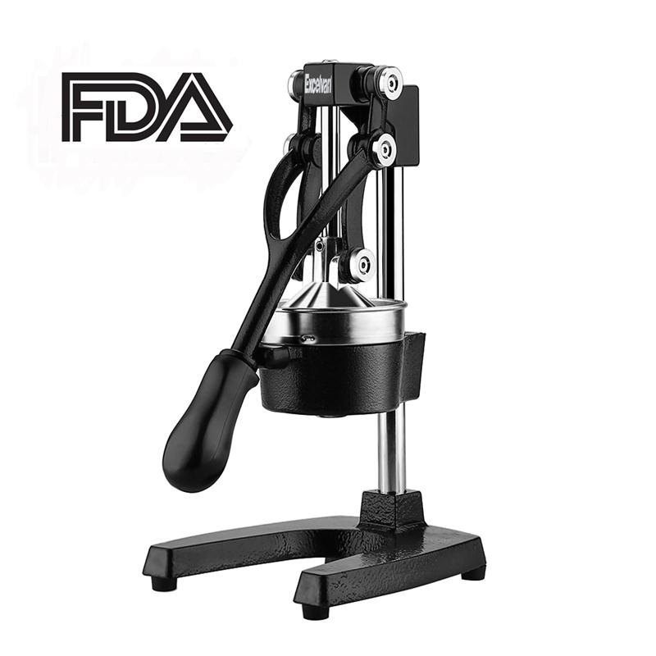

**Assembly View (Original)**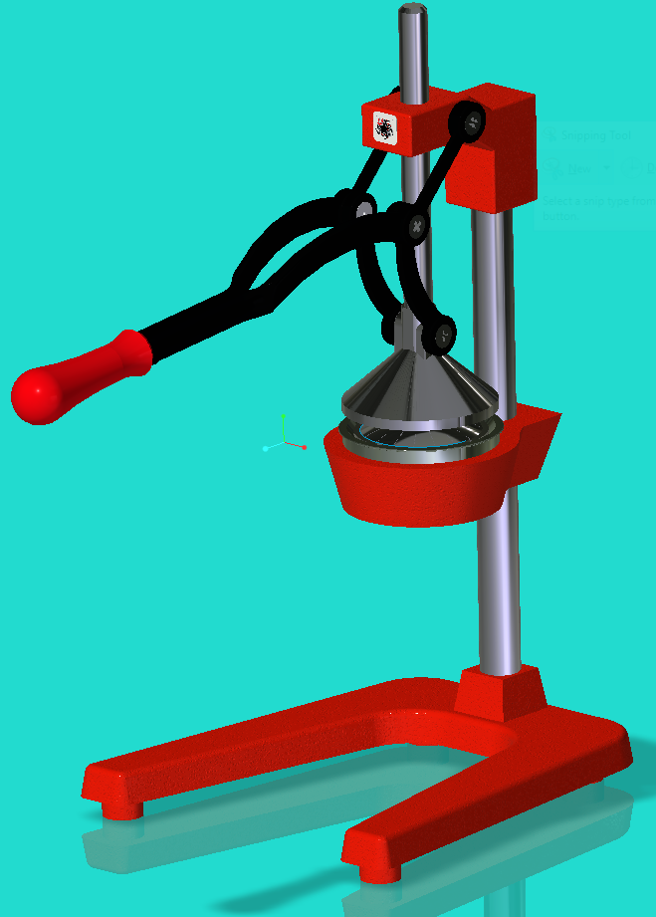

**Exploded View (Original)**

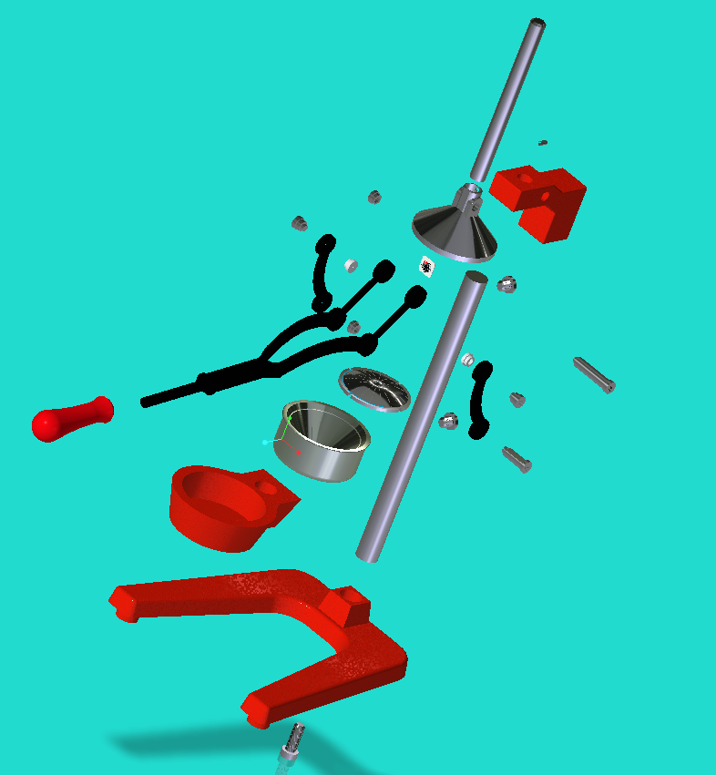

**Part Design and Description (Original)**

Base:

🡪 Number Used – 1

🡪 Dimensions – H = 0.79”, L = 11”, W = 7.5”

🡪 Volume – 25.6in3

🡪 Material – Grey Cast Iron

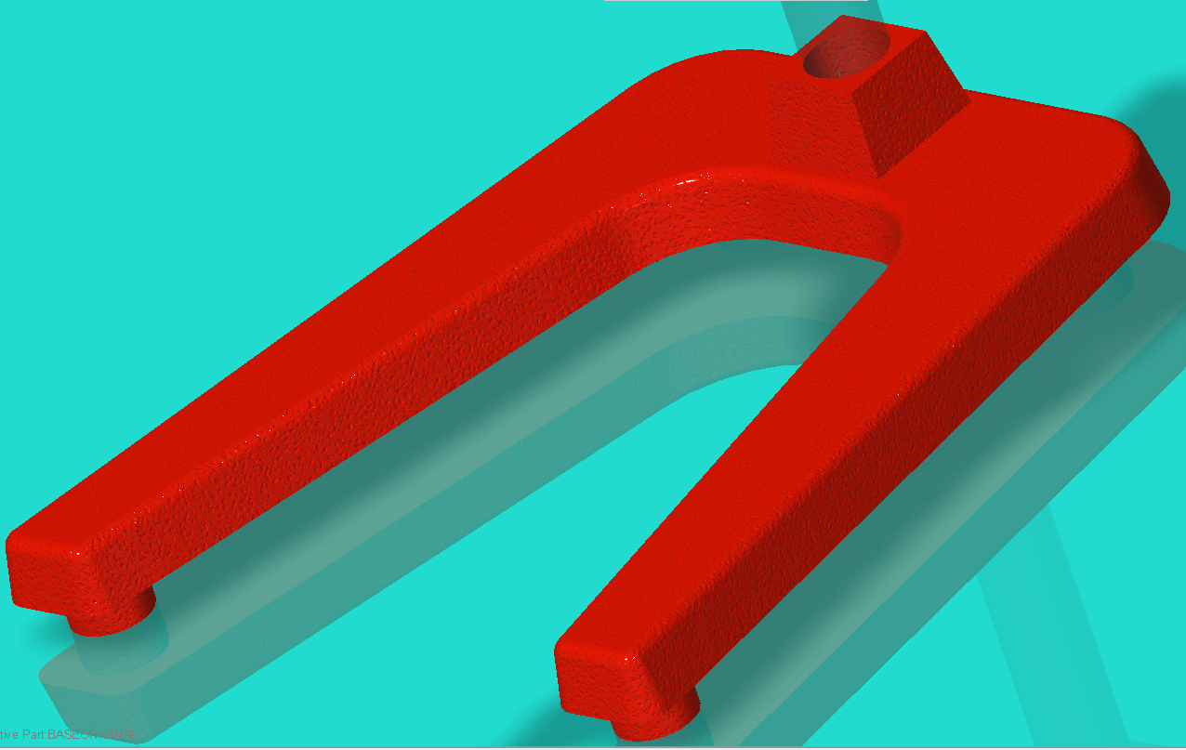

Main Rod:

🡪 Number Used – 1

🡪 Dimensions – 1” diameter, 14.3” length

🡪 Material – Stainless Steel

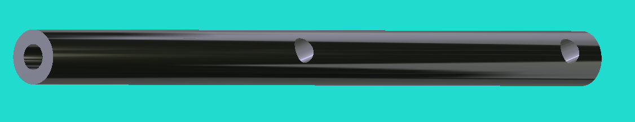

Upper Assembly Mount:

🡪 Number Used – 1

🡪 Dimensions – H = 3.2”, L=4.53”, W=1.6”

🡪 Volume – 9.77 in3

🡪 Material – Grey Cast Iron



Strainer and Funnel Mount:

🡪 Number Used – 1

🡪 Dimensions – H=1.6”, L=5.867, I.D.=3.767”

🡪 Volume – 11.03 in3

🡪 Material – Cast Iron



Press Rod:

🡪 Number Used – 1

🡪 Dimensions – .7” Diameter, L=8”

🡪 Material – Stainless Steel

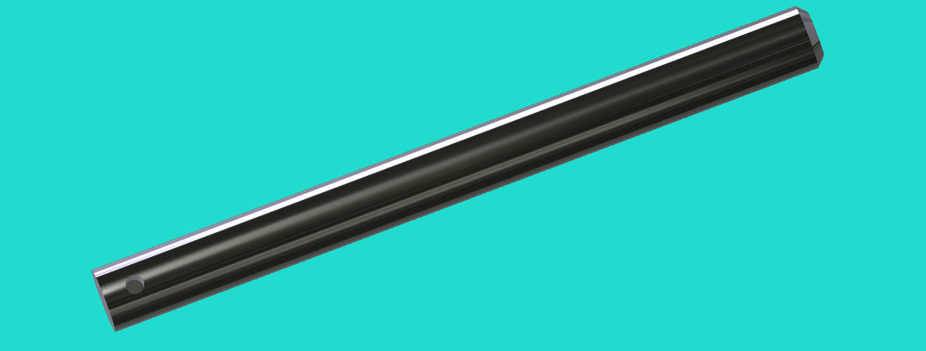

Press:

🡪 Number Used – 1

🡪 Dimensions – O.D.=3.767”, H=2.33”

🡪 Material – Stainless Steel

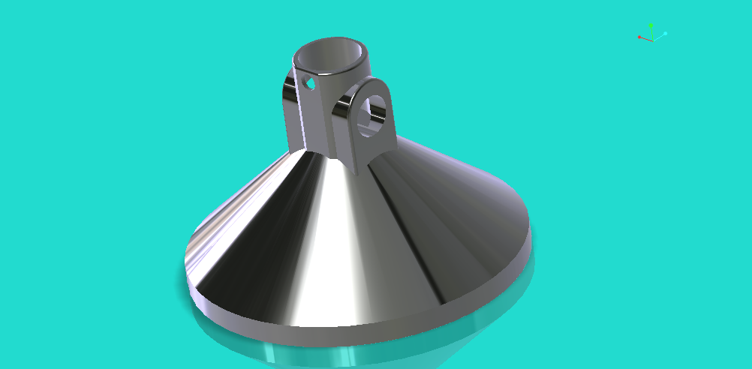

Press Handle:

🡪 Number Used – 1

🡪 Dimensions – L=12.53”

🡪 Material - Steel



Handle Grip:

🡪 Number Used – 1

🡪 Dimensions – L=4.267”

🡪 Material - Plastic



Lower Press Bracket:

🡪 Number Used – 2

🡪 Dimensions – L=2.67”

🡪 Material - Steel



Funnel:

🡪 Number Used – 1

🡪 Dimensions – O.D.=3.767”

🡪 Material – Stainless Steel

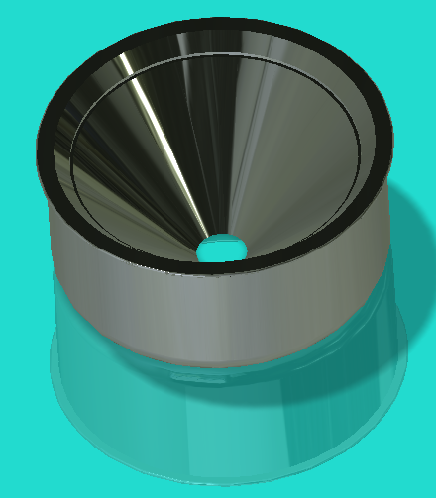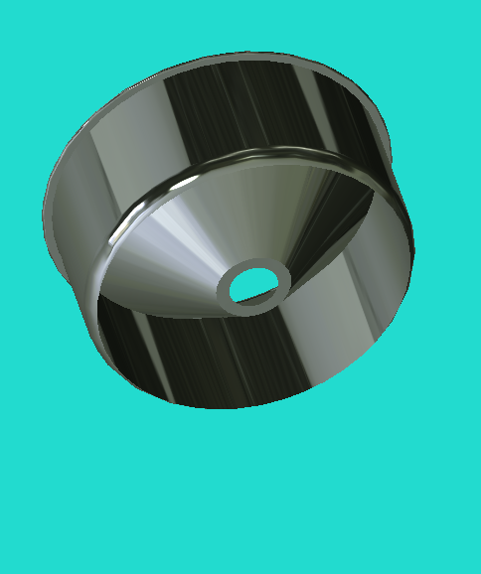

Squeezer:

🡪 Number Used – 1

🡪 Dimensions – Diameter=3.23”

🡪 Material – Stainless Steel

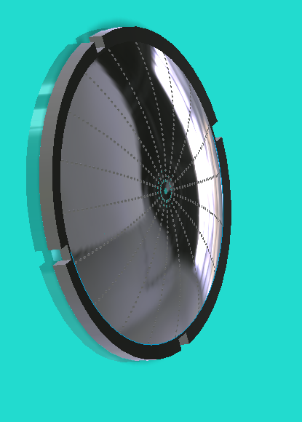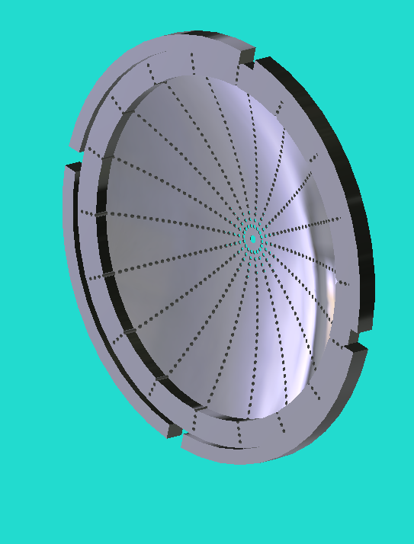 

Rod Bolts:

🡪 Number Used – 2

🡪 Dimensions – Pitch=0.04, L=.65”

🡪 Material – Galvanized Steel

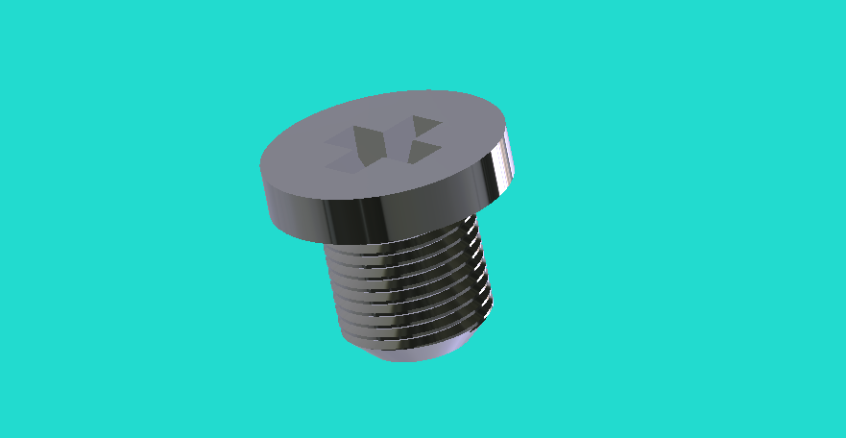

Main Support Rod Bolt:

🡪 Number Used – 1

🡪 Dimensions – Pitch=0.04, L=1.6”

🡪 Material – Galvanized Steel

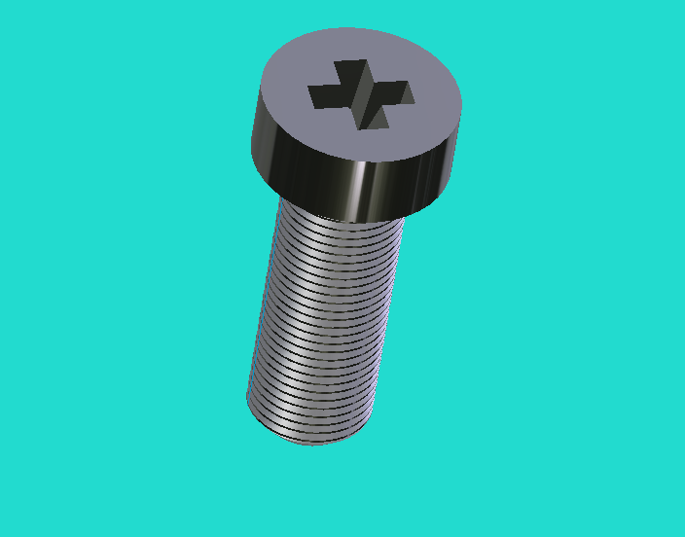

Press Cotter Pin:

🡪 Number Used – 1

🡪 Dimensions – L=.39”

🡪 Material - Steel

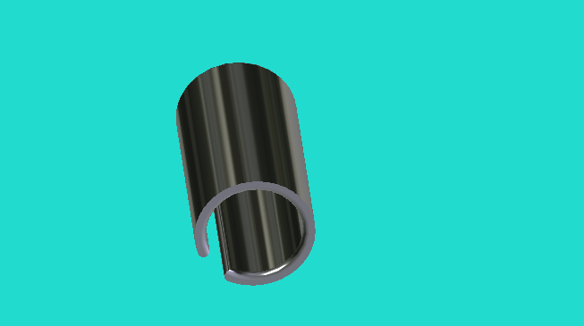

Press Mounting Bolt and Nut:

🡪 Number Used – 1

🡪 Dimensions – L=1.6”

🡪 Material – Stainless Steel

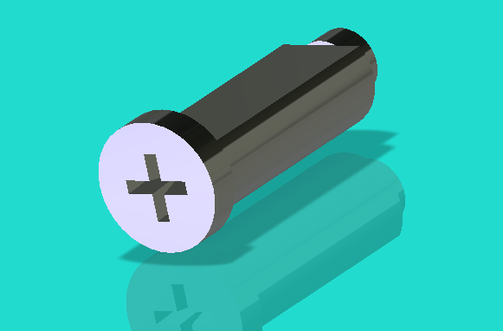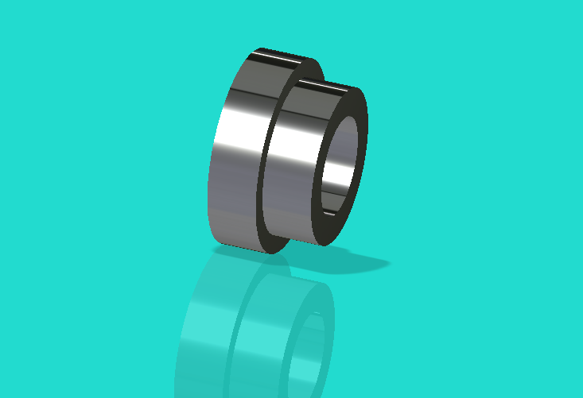

Lower Bracket Bolt:

🡪 Number Used – 2

🡪 Dimensions – Diameter=.47”, L=.55”

🡪 Material – Stainless Steel



Lower Bracket Nut:

🡪 Number Used – 2

🡪 Dimensions – Diameter=.47”, L=.6”

🡪 Material – Stainless Steel

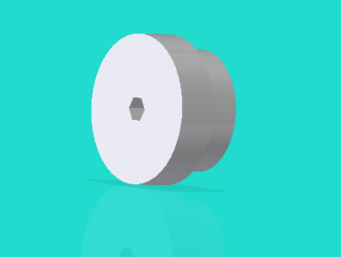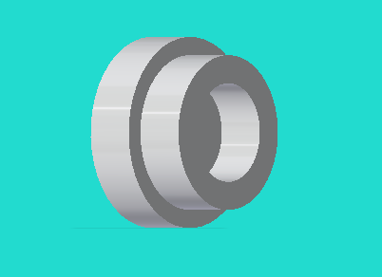

Handle Bolt and Nut:

🡪 Number Used – 1

🡪 Dimensions – Diameter=.47”, L=2.2”

🡪 Material – Stainless Steel



LAMAR LOGO (EXTRA):

🡪 In addition to the placard there are four rivots placed in the model which serve to hold it in place.



**Initial Take Away**

Upon initial inspection of the products design and components it was quickly identified were improvements could be made. The upper portion of the assembly presented the most complexity in terms of number of parts and product design so we put the majority of our focus in this area. Next, we turned to the base. This area seemed rather simple at first and we attempted to make some rather extreme changes such as combining the squeezer mount and base, but found that while most of these modifications would reduce the part number it would also drastically increase the amount of materials used. Thus, in the end we focused solely on the base and improving its design. By making these modification to the upper portion and base of the tool we were able to decrease the number of parts used as well as the complexity, making it easier to assemble and more importantly less expensive to manufacture.

**Improved Design:**

**Assembly View (Improved)**

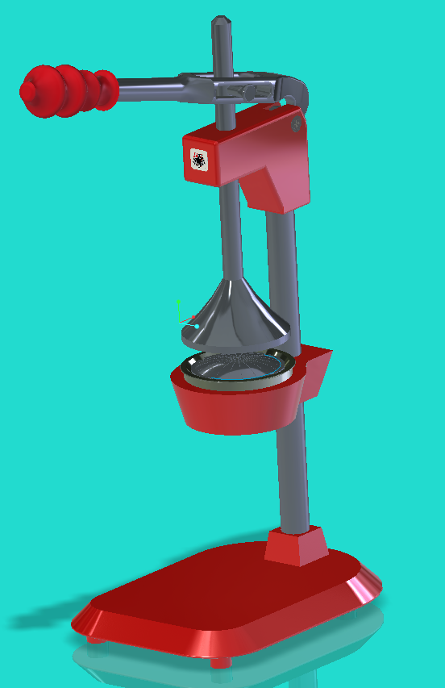

**Exploded View (Improved)**

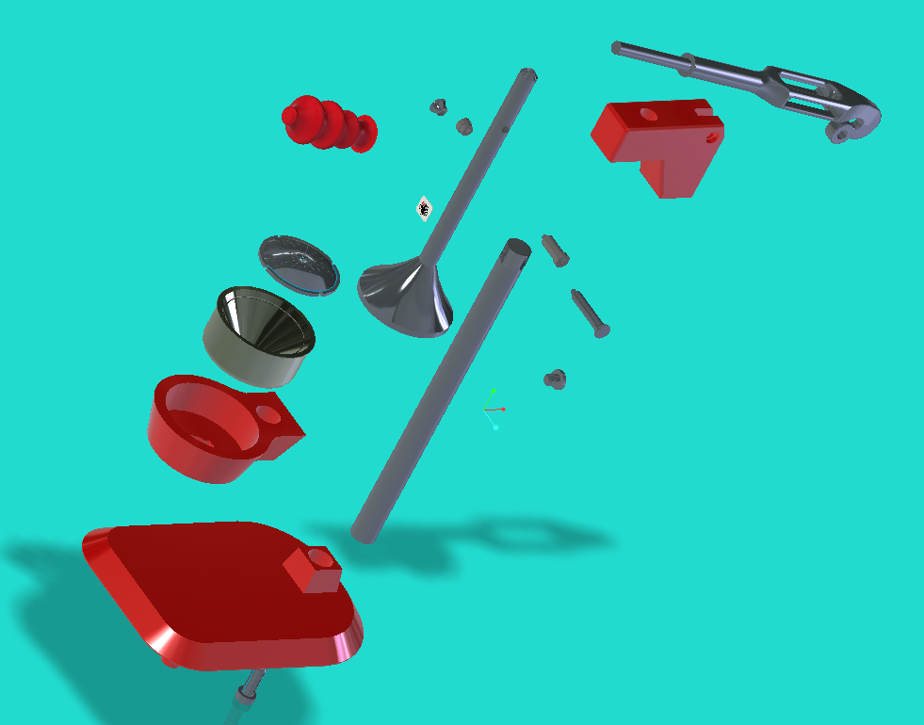

**Comments**

As seen from this improved design it can be immediately noticed that less parts are used and several parts are made of different materials. These improvements were crucial to the success of our project.

**Parts (Improved Only)**

Upper Mount:

🡪 Number Used – 1

🡪 Dimensions – H=3.5”, L=5”, W=1.6”

🡪 Material – Cast Aluminum (5052)

🡪 Volume – 16.69 in3

🡪 Comments – New 5052 Cast Aluminum will cause this new component to have a weight of 1.62 lbs. compared to a weight of 2.54 lbs. for the original upper mount.

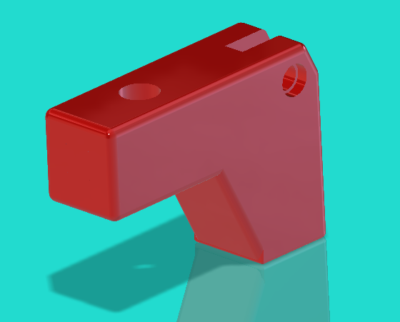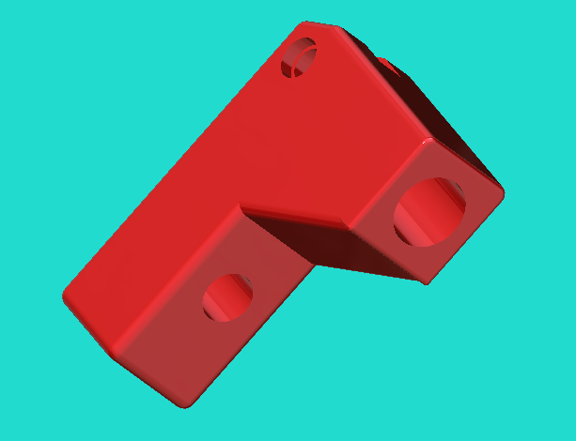

Press Handle:

🡪 Number Used – 1

🡪 Dimensions – L=14.4”

🡪 Material – Cast Aluminum (5052)

🡪 Volume – 7.57 in3

🡪 Comments – Improved design shortens working radius by shifting point of rotation behind the juicer and provides for a better means of force application

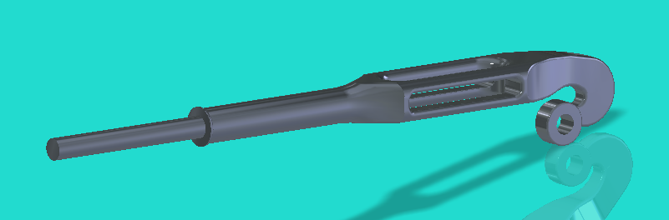

Press Handle Grip:

🡪 Number Used – 1

🡪 Dimensions – L=4.4”

🡪 Material – Plastic

🡪 Volume – 5 in3

🡪 Comments – New style of grip converts the old design for the average into a much more ergonomic design for comfortable handling and ease of use over long periods of time.

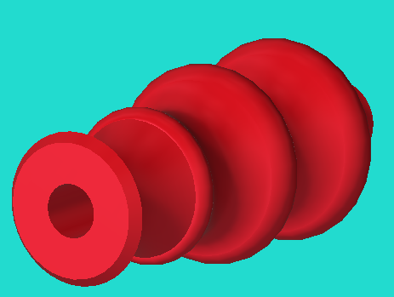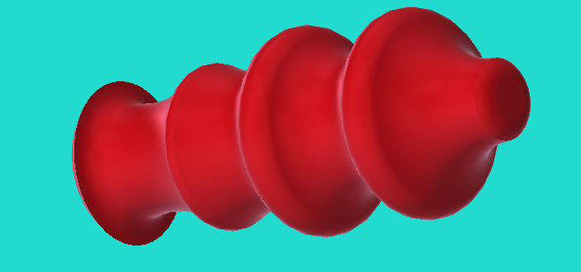

Press Rod/Press:

🡪 Number Used – 1

🡪 Dimensions – L=11.7", Base Diameter=3.767", Top Diameter=.7"

🡪 Material – Steel

🡪 Volume - 12.48 in3

🡪 Comments – Replaces the three components of the previously separate press and press rod

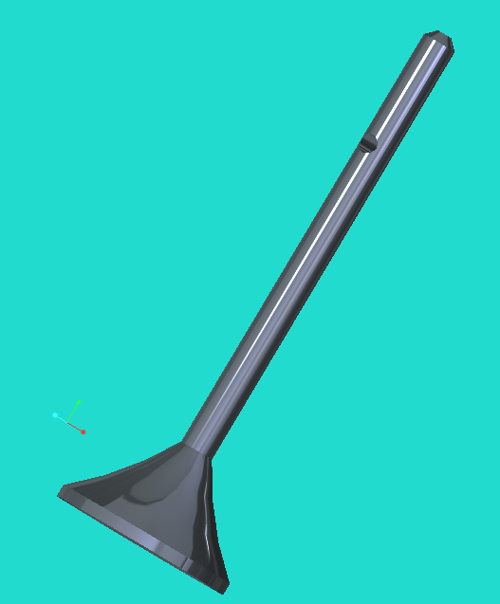 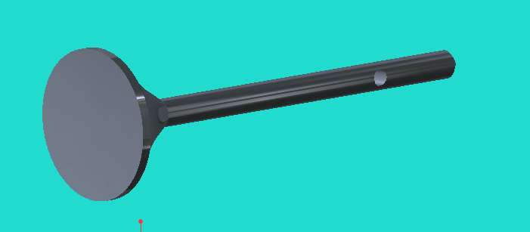

REPLACEMENT – (Lower Bracket 🡪 Press Rod/Press Slider and Nut)

🡪 Number Used – 1

🡪 Dimensions – L=2.3”, Diameter=.4”

🡪 Material – Stainless Steel

🡪 Volume – 0.303 in3 and 0.0625 in3

🡪 Comments – Slider finished and coated to allow for low friction contact with handle

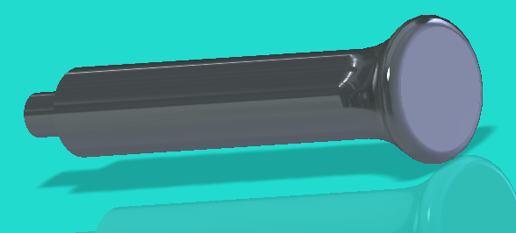 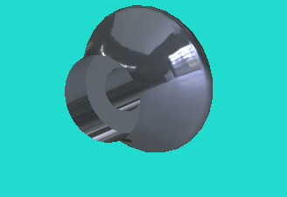

Assembly Base:

🡪 Number Used – 1

🡪 Dimensions – H=.79”, L=11”, W=7.5”

🡪 Material – 5052 Cast Aluminum

🡪 Volume – 25.3in3

🡪 Comments – New piece will be milled, turned, and drilled from a solid piece of cast aluminum which will decrease the functioning weight by 63% since they have nearly equal volumes.

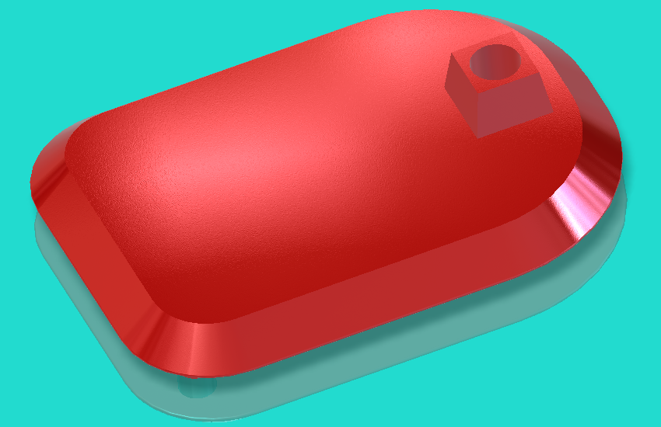

Main Rod:

🡪 Number Used – 1

🡪 Dimensions – 1” diameter, 14.3” length

🡪 Material – Stainless Steel

🡪 Volume – 10.94 in3

🡪 Comments – Threaded end eliminates the need for another bolt, though the need for the exacting process of making near perfect threads for upper mount alignment could raise the cost dramatically. Thus to mitigate this possibility we will use the threads as a guide with a sealing agent placed on the threads to hold the assembly in the appropriate position.

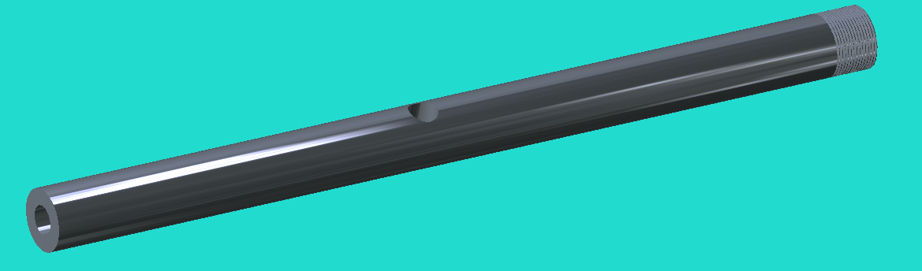

**Part Manufacturing Plan**

When manufacturing the improved design of the combined press and press rod, three operation are used. These three operations include turning, drilling, and milling which are applied to a 4” O.D. X 11.709” piece of steel bar stock. This piece will for the most part be custom made by an outside company using specific manufacturing plans developed by our team.

Plan Procedure

1. Obtain 4” diameter steel bar stock and cut to 11.709” length with band saw.
2. Place 4” O.D. X 11.709” steel bar stock in machine lathe and rough cut until overall diameter is 3.767”
3. Next, turn the outer 9.43” of the bar down to .7” in diameter initially making rough cuts, but finishing cuts will conclude.
4. Chamfer the adjacent 1.9” of the unaltered 3.767” diameter bar from 3.767” down to .7” with a combination of rough and finishing cuts leaving a .25” lip on the edge of the bar at 3.767”
5. Chamfer .25” on the end tooled down to .7” to .15”
6. Take work piece from the lathe and set it up on a universal milling machine for facing, then face the end still at 3.767 with a slight gradient to form a dome shape.
7. Take work piece from mill and place in CNC machine to drill a .4” diameter hole centered on the .7” diameter length of the bar 2.6” from this tooled down end.
8. After completion of this rough part a chrome coating will be applied for aesthetic quality.

Chamfer

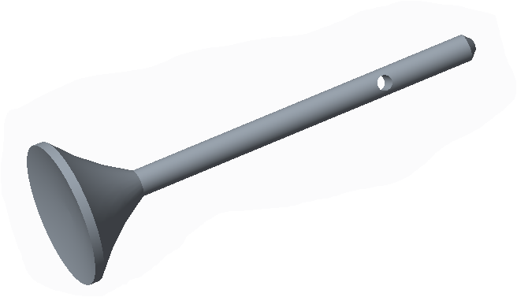

Chamfer

Turning

Milling

Drilling

**Bill of Material (BOM)**

**Comparison (Original vs. Improved)**

**BOM - Original**

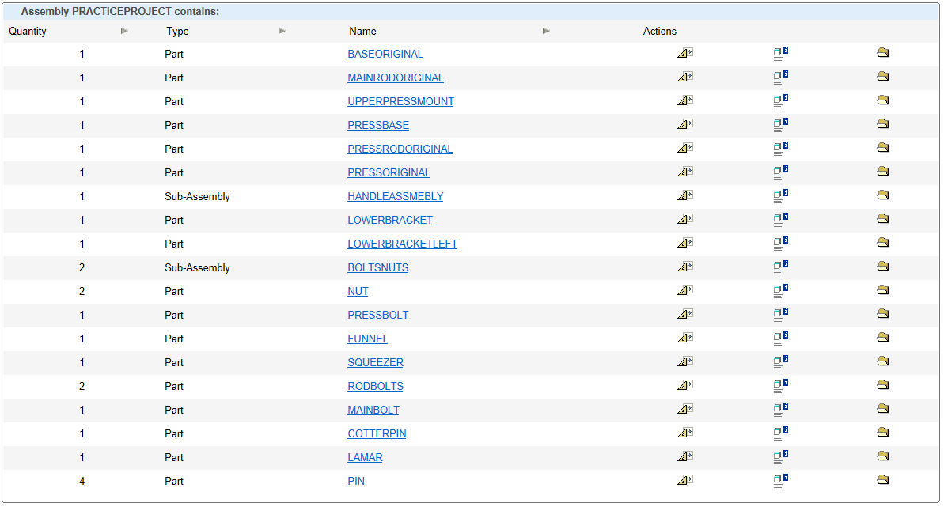

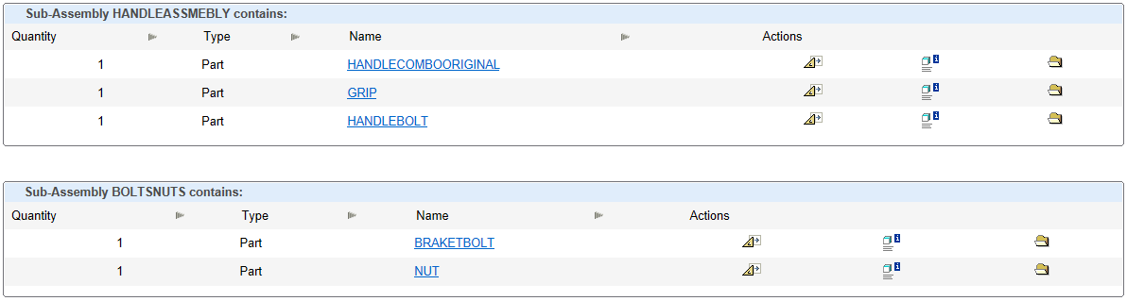

**BOM – Improved**

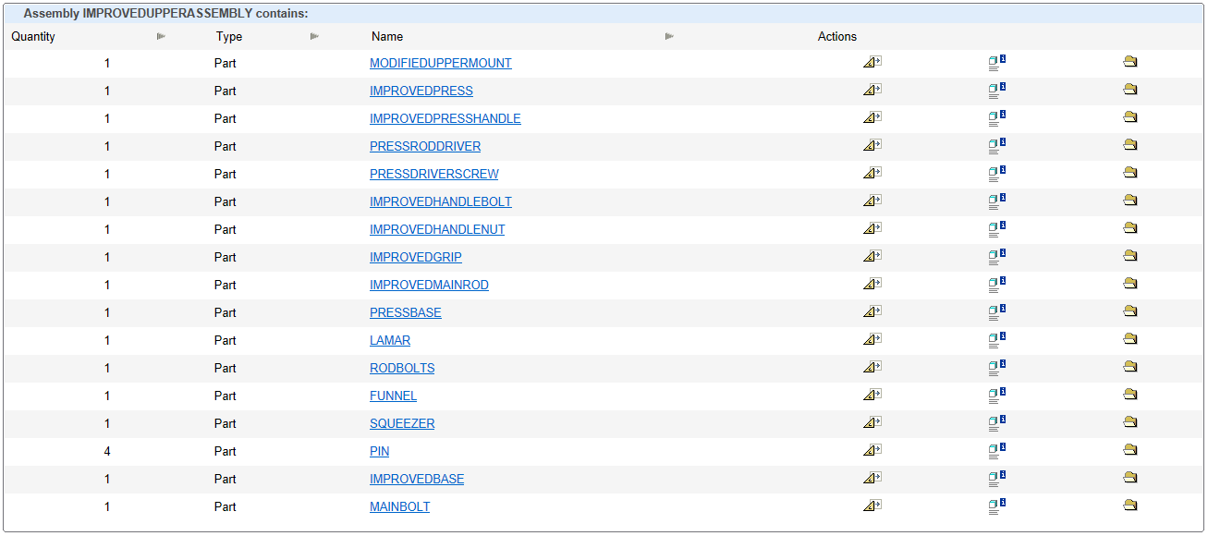

**Part Quantities**

In total the following assemblies had for 🡪

* + Original = 29 parts
  + Improved = 20 Parts

With a total discrepancy of 9 parts after improvement meaning that from initial appearance the improved design seems to honor its purpose of providing for few parts with simple construction.

**Comments on Complexity and Quality**

From this initial count, other considerations can be made. For instance, the Lamar university placard for aesthetic reasons can be counted as null, non-value adding parts. When these pieces are omitted the total part, count go from 29 & 20 to 24 & 15. This reveals that the basic functional parts of the machine were reduced nearly 40% by the improved design which would undoubtedly make it easier to assemble in any process. From the complexity aspect of actual assembly, part for part, the improved design could present some more opportunities for mistakes however, the elimination of all redundant parts makes the design some clear and concise and prevents the confusion of how many parts should be allocated since every functional part should only be allocated once.

**DFA (Design for Assembly) Analysis**

When an engineering team is tasked with the assignment of designing a new product such as the one we are examining many factors must be considered in order to successfully bring it from concept to market. Cost factors such as time, capital, and resources must be kept to minimum by choosing the most efficient materials, the quickest process flows, and least expensive methods of production. Variable factors such as labor utilization, part variation, and inventory control must be maintained in a stable condition in order to provide for accurate estimates on cost and lead times and also be kept at the lowest level possible for cost savings. Design factors such as ease of assembly and product complexity must be evaluated meticulously to insure that error proofing is incorporated into the final product so that mistakes in production are limited. The design for assembly (DFA) methodology provides a framework for accomplishing these lofty goals in development and design. When DFA is proper implemented it is extremely effective in optimizing procedural steps, part usage, and overall design efficiency.

By definition, DFA is a tool which consists of a body of techniques which serve to develop products that can be easily assembled. When utilized by design teams, this tool can aid in developing products that will be brought to realization at a minimum cost to the manufacturer. It achieves this through a set of guidelines which focuses on the quantity of parts, the handling of these parts, and the methods of assembly for these parts into a final assembly. Implementing this set of guidelines can be done through several methods that have been developed through the years. The first is fairly basic and essential reduces to a set of rules and guidelines to follow. These rules are not quantitative and must be interpreted into actual parameters by engineers and then applied to the design. The second method builds upon the first and incorporates a numeric value system that rates the assemblability of each part. These ratings or scores are then accumulated for the complete design and used as a guide to measure its quality. Using this scoring system, the design is then re-engineered to minimize this value by focus on parts which weigh most on the score. While this method provides a highly-structured methodology it still requires the user to have some competency. The third method is the most recently developed of the three and relies on automation to run the entire process. This method is simplistic in nature and only requires the user to set the design parameters required for the overall design. Once design rules are set the system can minimize the score on its own by repeated applying the rules through an algorithm.

However different these approaches seem to be, they all incorporate the same stepwise procedure. First, an initial design must be constructed that serves as the basis and includes the products information, functional requirements, and standardized parts. Next, a practical part count is determined to set the upper bound for desired parts. This is followed by an evaluation for identification of quality, handling, and process rearrangement improvement areas. Once complete the next step is to reduce secondary operations. Finally, the new design is analyzed and the process is repeated until the optimal design is found.

**DFA Guidelines**

DFA Guidelines are standard for the most part. The following is a summary of those general guidelines

1. Make the design simple and seek to decrease the number of parts used
2. Consider standardizing common parts to reduce variability
3. Design products with parts that are easy to fabricate
4. Avoid designing products with un-needed surface finishing requirements
5. Assess assembly for error-proofing opportunities
6. Design parts that are easily aligned and not cumbersome to handle
7. Minimize flexible parts that are susceptible to wear
8. Design products that are easy to assemble
9. Make any fastening or connecting components easy to join
10. Make product that can be modularly produced
11. Products should be designed that can be produced through automated production
12. Design circuit boards that are printed for assembly

**Areas of Improvement**

In our project, we applied DFA to two main parts of our product that seemed to show areas where improvements could be made. In these two areas, we were able to redesign the assemblies to reduce the number of parts used as well and introduce new lighter material that will provide a product that is easier for the consumer to use as well as possibly providing reduced shipping cost. These achievements were made by rethinking how this tool operates and then applying knowledge gained through our education to re-engineer its design.

The first area of improvement, which also presented the greatest opportunity for improvement, was the upper press mount. In this area, we took the existing design and considered several alternatives. Knowing that this was the area were the most force would be applied we considered a gear type design at first, but then realized this would result in parts that would increase the complexity of the tool due to intricate parts. After careful consideration, we final agreed upon a slider type design that took the existing press handle which applied force on either side, at an angle, and offset from the tool and placed it directly over the top of the upper mount. This reduced several parts and also allow us to reduce the working radius of the press for safer operation. Next, we turned our attention to the press itself. We simplified the part design by eliminating the three-piece construction and making the press and press rod one solid turned part. Once these improvements were implemented we found we could change the material makeup of the upper mount since it would experience reduced stress from the force being placed directly overhead. We changed its cast iron composition to cast aluminum which might present a weaker structural profile, but provide large savings in terms of material cost and weight.

The next area we turned our attention to was the base. The original base had a unique shape which required a casting process to produce. After evaluation, our new design created a solid base that could be machined using a CNC mill. In addition to this we also changed the material used. Since the base was a solid part now and could handle a higher amount of stress we opted to use aluminum over cast iron which once again provided cost and weight savings.

Other Improvements

In addition to the major improvements above other improvements were made in part reduction, ergonomics, and material efficiency. For part reductions, the use of a threaded top to adhere the main rod to the upper mount eliminated the need for a bolt to hold it in place, the lower brackets were eliminated from the design all together with the advent of the overhead design, and this modification also eliminated many bolts and nuts from the design. In ergonomics, the grip was redesigned to allow for the user to hold it with ease and not have odd pressure points on their hands. The material efficiency came from also changing the material makeup of the funnel support to stainless steel for corrosive purposes.

Improved Area Pictures

- Upper Mount

Original Improved

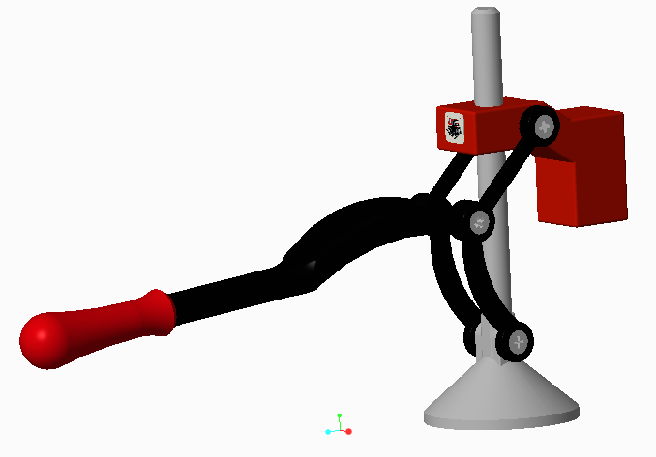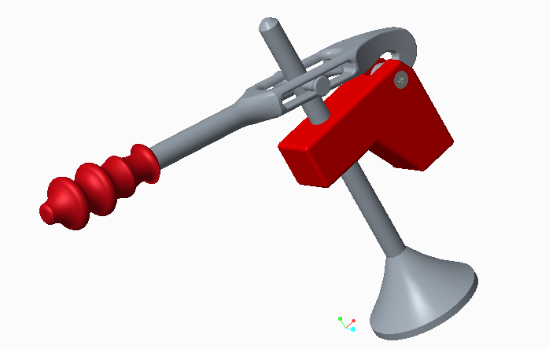

- Base

Original Improved

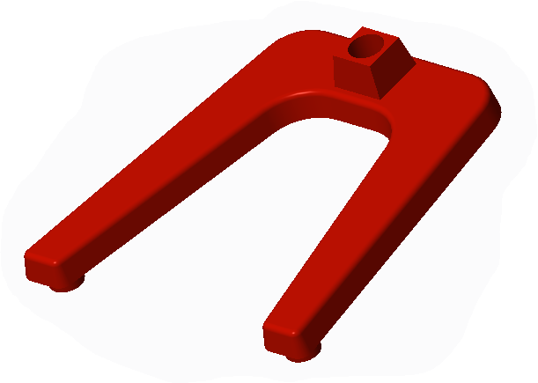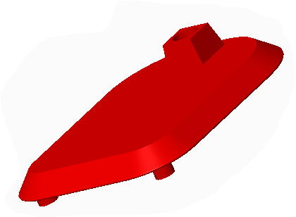

**Redesigned Parts (DFA & DFM)**

Redesigned parts for the upper assembly

|  |  |
| --- | --- |
| Original | Improved |

- Press Components

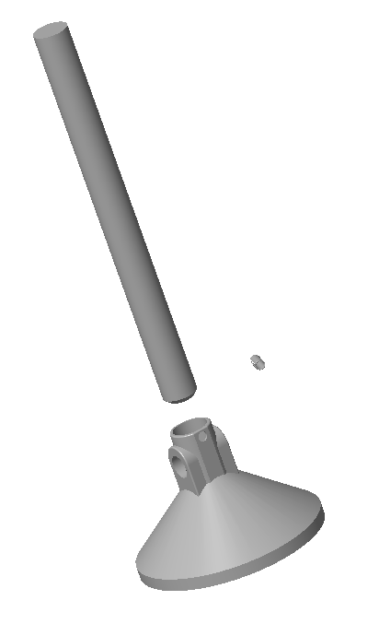 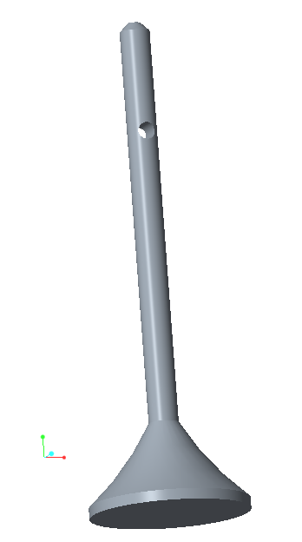

- Upper Mount

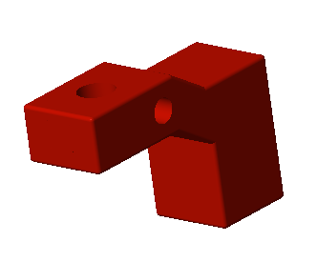 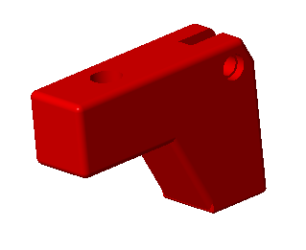

- Handle, Grip, Nuts, and Bolts

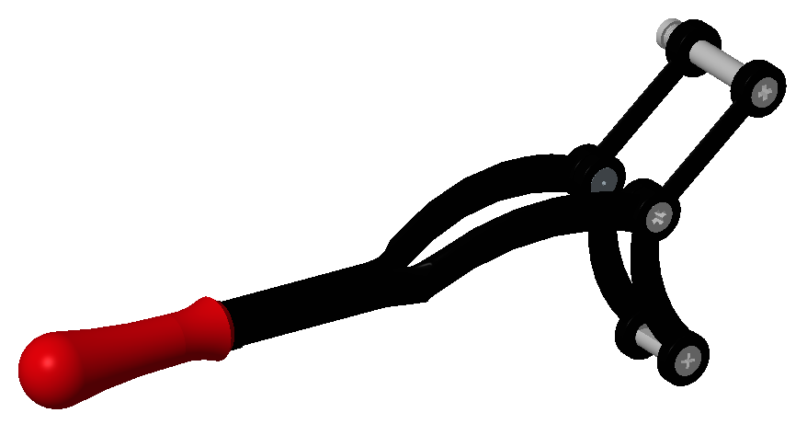 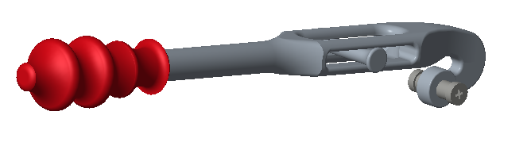

Redesigned base

|  |  |
| --- | --- |
| Original | Improved |

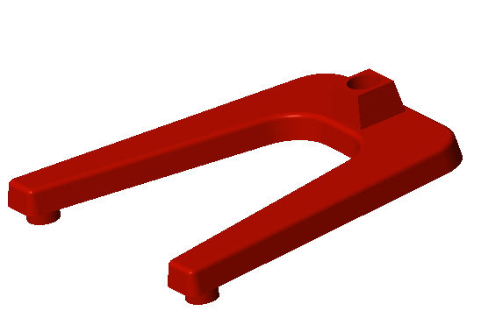 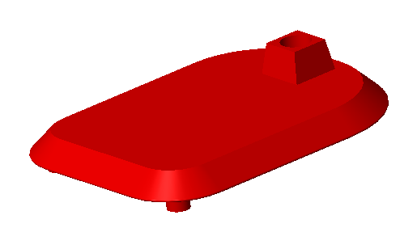

Other Redesigned Areas

|  |  |
| --- | --- |
| Original | Improved |

- Main Rod (Upper Connection)

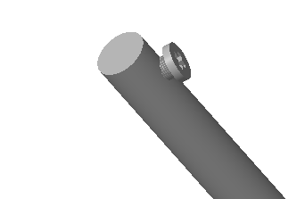 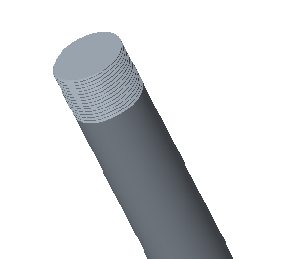

**Comparison (Original Vs. Improved)**

Comparison by Exploded Views

**Original**  versus **Improved**

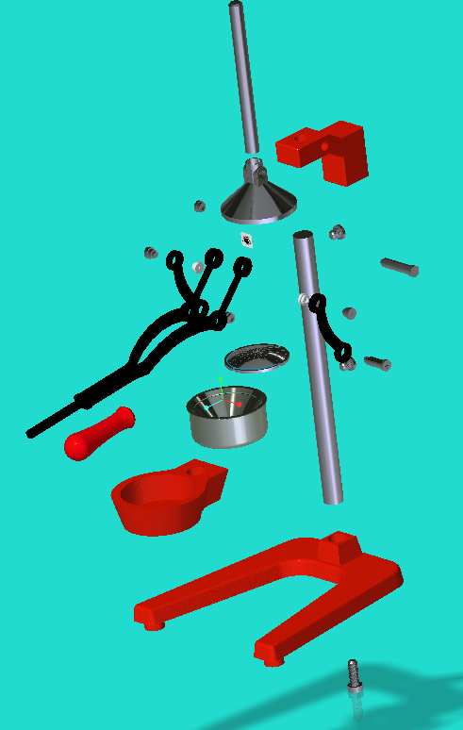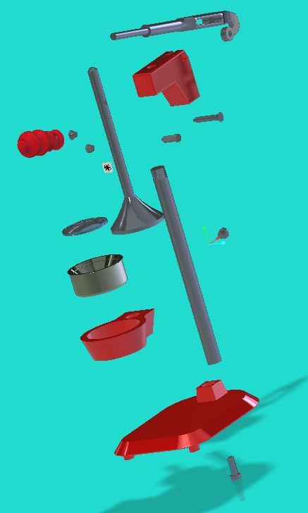

Comparison by Area of Force Generation, Working Profile, and Stress points

**Original**  versus **Improved**

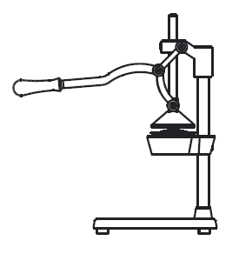 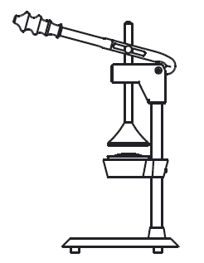

Applied Force

Applied Force

*Stress in bilateral direction*

Comparison by Drawings

**Original**  versus **Improved**

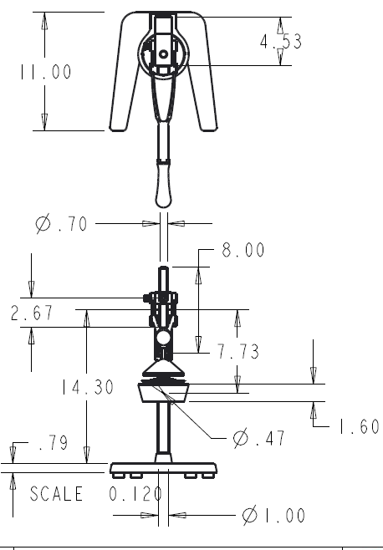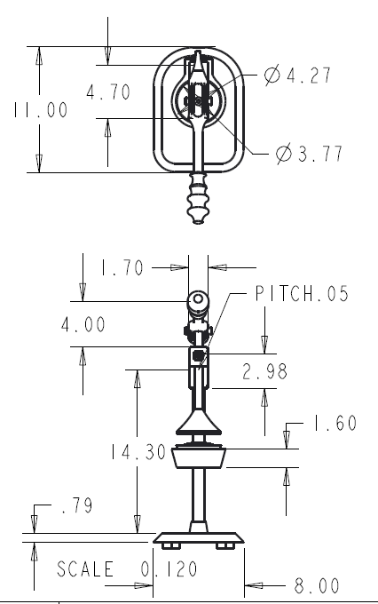

Comparison by Material Composition (Based on Internet Data)

|  |  |  |
| --- | --- | --- |
| Metric - Unit | Grey Cast Iron | Cast Aluminum (5052) |
| Cost - $/lb. | $0.7095 | $0.55 |
| Weight - lb./in3 | 0.2558 lbs. | 0.0975 lbs. |
| Tensile Yield Strength | 14,000 - 41,000 PSI | 11,000 – 38,000 PSI |
| Poisson’s Ratio | 0.26 | 0.33 |
| Hardness (Brinell) | 160 | 47 |

Comments on Materials – As seen above the change from grey cast iron to 5052 cast aluminum does come with some drawbacks in strength and hardness, but we believe the improved design should facilitate the new material by altering the stress points on the juicer.

**Results:**

**Table**

|  |  |  |  |
| --- | --- | --- | --- |
| **No.** | **Metric** | **Original Design** | **Improved Design** |
| **1** | **Number of Parts** | 29 | 24 |
| **2** | **# of Subassemblies** | 2 | 0 |
| **3** | **Part Proliferation** | 21 | 17 |
| **4** | **Manufacturability** | Medium Complexity | Medium Complexity |
| **5** | **Assemblability** | Medium Complexity | Simple |
| **6** | **Cost Factor** | Expensive Materials | Cheap Materials |
| **7** | **Working Profile** | Wide | Compact |
| **8** | **Weight** | Heavy | Light |
| **9** | **Ergonomic Assessment** | Grip – Designed For the average  Handle Operation – over front with force being applied in an awkward direction | Grip – Designed for comfort  Handle Operation – on top with force applied in a more natural direction |
| **10** | **Safety Factor** | Pinch point, Sharp edges, line of fire, large working radius, easy to tip over | Smooth finish, compact operation, confined components, hard to tip over |

**Summary**

From our analysis and examination of Excelvan’s industrial press juicer using the tools and skillset we have developed through this course we were able to identify, process, redesign and implement a plan to create a product that is easier and cheaper to produce and yields a host of other benefits as well. Some of the other benefits we recognized came from cost savings on shipping from a lighter product, easier marketing with a more unique design, and an easier to assemble product with fewer repeated parts. These other benefits included small measures which might not always be considered, but can have a large impact on the final profit realized. However, we did find some potential problems to the design which will need to be mitigated through alternative means. The main issue we saw was the possible occurrence of galvanic corrosion from the use of aluminum alloys with steel. To alleviate this problem, we suggest power coating these components to put a barrier between the two metals. Aside from the other few small issues, we were able to design a new and more effective product which provides for decreased cost without decreased functionality.

**Conclusions**

Throughout the process of evaluating this design we employed many tools used in industrial environments and found relative amounts of success. It gave us a chance to explore the possibilities of applying our knowledge and what could ultimately result. This project also helped to build or industrial engineering skillset in many ways, by pushing us to find solutions with what we were given and improving situations that didn’t have any apparent flaws. These skills will hopefully carry over into or future professions and aid us in or quest to provide the best improvements in efficiency and quality for those we work for.

**Team Contribution**

Major Contribution Areas (Owner of each part)

Isaiah Gerald – Models, Report

Raghda Ajel – PowerPoint, Video Presentation

Minor Contribution Areas

Isaiah Gerald – Original Model, Original Model Components, Improved Model Assembly, Improved Model Components, Report Format, Report Body, and Content, PowerPoint Editing, Video Presenter

Raghda Ajel – PowerPoint Construction and Content, PowerPoint Format, Video Presenter, Original Model, Original Model Components, Improved Model Assembly, Improved Model Components, Report Editing

**References**

(Rose-Hulman), David Stienstra. n.d. "Introduction to Design for (Cost Effective) Assembly and Manufacturing." *Georgia Tech .* Accessed March 31, 2017. http://me.gatech.edu/files/capstone/L071ME4182DFA.

7329873 Canada Ltd. 2016. *Grey Cast Iron.* August 6. http://www.makeitfrom.com/material-properties/Grey-Cast-Iron.

ASM Aerospace Specification Metals Inc. . n.d. *Aluminum 5052-O - ASM Material Data Sheet - MatWeb.* http://asm.matweb.com/search/SpecificMaterial.asp?bassnum=MA5052O.

Haresh Khemani, Lamar Stonecypher. 2008. *Applications of CAD Software: What is Solid Modeling?* 12 8. Accessed April 5, 2017. http://www.brighthubengineering.com/cad-autocad-reviews-tips/19623-applications-of-cad-software-what-is-solid-modeling/.

Hoffman, Christoph M. n.d. "Solid Modeling." *Purdue University.* Accessed March 30, 2017. https://www.cs.purdue.edu/cgvlab/papers/cmh/CompGeomHandbook56.pdf.

Hongxin Zhang, Jieqing Feng. 2007. "Introduction to." *ZJU.* January 15. Accessed March 30, 2017. http://www.cad.zju.edu.cn/home/zhx/GM/015/00-ism.pdf.

Jarek R. Rossignac, Aristides A. G. Requicha. 1999. "Solid Modeling." *Lsi Upc.* Accessed March 30, 2017. http://www.lsi.upc.edu/~virtual/SGI/docs/3.%20Further%20Reading/Solid%20Modeling%20(1999).pdf.

Metal-Technologies. n.d. "History of Metal Casting." *metal-technologies.com.* Accessed April 5, 2017. http://www.metal-technologies.com/docs/default-source/education/historyofmetalcasting.pdf?sfvrsn=8.

Mid-Atlantic Casting. n.d. "A Guide to Aluminum Casting Alloys." *Mid-Atlantic Casting.* Accessed 4 11, 2017. http://www.ewp.rpi.edu/hartford/~ernesto/F2010/EP2/Materials4Students/Lenny/Guide-Al-casting-alloys_FEB05.pdf.

Shapiro, Vadim. 2001. "Solid Modeling ." *University of WIsconsin Madison.* October. Accessed March 30, 2017. https://spatial.engr.wisc.edu/wp-uploads/2014/04/2001-2.pdf.

Toogood, P.Eng Ph.D Roger. 2015. *CREO Parametric 3.0 Tutorial (ISBN-13: 978-1585039487).* Alberta: SDC Publications.